THE SUPREME COURT AND POLICY
[Slide 1]
- Some say the Court should only settle disputes, but it is clear that it does much more than that
  - It is clearly more than this
- The Question of Judicial Activism
  - Acts that go beyond simple interpretation, to creating laws
  - (The Problem on the term, JUDICIAL ACTIVISM: There are two parallel understandings of judicial activism; one refers to a derogatory way the justice thinks or acts or; the other referring to a court going beyond simply interpreting the law to creating the law or ordering some particular action.)
    - Judicial Review
      - Started with Marbury vs. Madison
        - JUDICIAL ACTIVISM comes on its own during the 20th century (It says that the court can direct or would force Madison to appoint Marbury)
- Aggressively reviewing and overturning Federal or Congressional Statutes

[Slide 2]
- Judicial Review
  - Overturning old supreme court cases
    - Plessy vs. Ferguson and Brown vs. Board of Education
  - Political Issues
    - Bush versus Gore
  - Remedies
    - The Court ordering some action to right a governmental wrong
    - Actually forcing people to do things in order to fix a problem
    - Court requiring other government agencies to do something

[Slide 3]
- BUSH versus GORE
  - Background
    - The 2000 presidential election was really close
      - Really Really close
      - I’m not kidding.
      - Here’s how the Popular Vote broke down:
        - BUSH: 50,456,002 votes
        - GORE: 50,999,897 votes
          - Two things become apparent
            - Notice Gore actually won more popular votes (3rd time in history)
            - For comparison, in 2012
              - OBAMA: 65,899,660 votes
              - ROMNEY: 60,932,152 votes

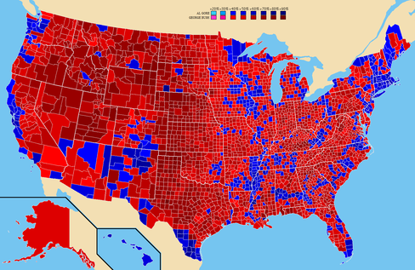
[Slide 4]
Picture: How each individual country voted in the 2000 elections (Bush vs. Gore)

*The darker the red, the higher percentage of Republican votes (rural areas)
*The darker the blue, the higher percentage of Democratic votes (major cities, metropolitan cities)

[Slide 5]
BUSH VERSUS GORE
- Essentially the election was going to come down to Florida
  - In 2000, Florida had 25 electoral votes, and getting Florida would push either candidate above the necessary 270 (If the candidate does not get Florida, the candidate loses)
  - Florida was even closer!
    - Bush was determined to have won Florida, but only by 1,784 votes
      - A vote this close was required to have a recount, since it is much smaller than the margin of error
    - This is where things start to get a bit crazy.
      - Florida automatically recounts ballots by machine
        - Al Gore requests that certain key counties recount ballots by hand (He is allowed to do this under Florida State Law)
      - After some confusion, 7 days later Florida declares that Bush won Florida and thus the presidency.
      - Then everyone sues everybody else.
        - Al Gore’s supporters (supposedly without Gore’s knowledge) sues the State of Florida and Bush supporters
        - Bush supporters countersue

[Slide 6]
BUSH VERSUS GORE
- This went first to the Florida Supreme Court (It takes the case up immediately)
  - Then quickly to the US Supreme Court
- The Florida Supreme Court ordered a manual recount
  - Recount all the votes in a few countries by hand (The FL Supreme Court chooses the counties instead of Al Gore)
    - Look at rejected ballots again (Ballots were punch card ballots)
  - The US Supreme Court stopped this and took up the case themselves.
- Fundamental Questions:
  - Was the recount constitutional?
    - If not, how do we pick a president?
- Decisions
  - The Florida recount violated the 14th amendment (Standard of Equal Protection of the Law)
    - Can’t treat some votes as if they are more special than others
    - The only thing the Supreme Court has is the original decision by Florida, which we have to go by. Bush wins the election.
  - They also made a per curiam decision
    - It only applies for this one case. Does not become precedent.

[Slide 7]
SUPREME COURT and INTERPRETATION

- The Debate over Interpretation
  - How should you look at the Constitution? (The Constitution is quite vague)
    - Original Intent/Strict Constitutionalism
      - Guide interpretation by what the intent of the founders were and what the text says (Strictly, literally)
    - Opponents/Judicial Activism
      - We should reconcile the fundamental principles of the Constitution with the changing conditions of America (The principles are more important and should be used in guiding the decision, not the wording)
    - How should we proceed?

[Slide 8]
THE SUPREME COURT and OUTSIDERS

- Social movements
  - Most get things done In the Supreme Court
    - Test Case – a case designed to test the constitutionality of a law (Organic cases on the other hand, is another type of case that originates in original or real disputes)
  - Friends of the Courts (People outside the courts can influence the court in providing opinions)
    - Help courts keep track of public opinion
    - Public Opinion
      - Courts are still swayed by public opinion even though they are designed to be insulated from it

